
SECTION 7 Part 135 GH 4A Part 133 GH 4L
Congested Area Plan
Operator: Guardian Helicopters, Inc
67 D STREET Phone (818) 442-9904
Fillmore CA. 93015 FAX (818) 442-9901
PROJECT: EQUIPMENT SETTING WORK ORDER #: GHI Q2021-427
ADDRESS: 15800 ROSCOE BLVD CITY : VAN NUYS STATE: CA
LANDING ZONE LATITUDE 34°13'2.49"N LONGITUDE 118°28'58.28"W

CONTACTOR: PERMACITY PHONE#: 888-991-9912 CELL: 323-481-9876
1415 N BATAVIA ST ORANGE CA 92867

CONTACT ON SITE: RON WILSON PHONE#: 323-481-9876
PILOT’S NAME(S):
1. JOHN OLSON CERT #: 2769166
2. BUCKEY MACKAY CERT #: 2778051
3. MICHAEL KLINK CERT#: 3018828
4. IAN GOODALE CERT#: 3741973
5. ROSS GOULET CERT#: 3396777
TYPE OF AIRCRAFT:
BHT 205 N# N216GH A/C CATEGORY: STANDARD
BHT 205 N# N211GH A/C CATEGORY: STANDARD

IF SAFETY DICTATES AND OR THE CUSTOMER REQUESTS ADDITIONAL LIFTS THE LIFTS WILL BE CONDUCTED REMAINING WITHIN THE APPROVED TIME PARAMETERS.
TYPE OF LIFTS: (0) (4) A/C UNITS MAX 3400 LBS LOAD:EXT CL B
TYPE OF ITEM LIFTING: AERODYNAMIC NON- AERODYNAMIC LONG LINE: _____(NO)XXX (YES) LESS 25 FT RIGGING 100 FT LONGLINE = MAX 125 FT (LENGTH) OPERATIONAL ALTITUDE: < 250 AGL STREET CLOSING: (N0) XX (YES)
DATE AND TIMES OPERATION WILL BEGIN AND TERMINATE:
FLIGHT DATES | TIME BEGIN | TIME END | TODAY’S DATE
11-21-2021 | SUNRISE | SUNSET | 11-10-2021
AGENCY NAME: | PHONE#: | PERSON NOTIFIED: | DATE:
VAN NUYS POLICE DEPARTMENT | 818-374-9500 | DISPATCH | 7-12-2021
VAN NUYS FIRE DEPARTMENT | 818-756-8690 | STATION 90 | 7-12-2021
VAN NUYS TOWER | 818-442-6500 |  | ON THE DAY
VAN NUYS ATC | 818-904-6166 |  | ON THE DAY
Evacuation Crowd Control Street Closure
□No Evacuated Structures Operator Yes □No
Evacuated Structures Contractor Contractor
□Operator

Part 135 GH 4A Part 133 GH 4L
Congested Area Plan

LIST OF BUILDINGS THAT SHALL BE UNOCCUPIED DURING OPERATIONS:

BUILDING DESCRIPTION/ADDRESS | REMARKS | METHOD
ANHEUSER BUSCH 15800 ROSCOE BLVD | VACANT DURING OPS | HAND DELIVER
ALL HOMES WITHIN RED OPERATING AREA | VACANT DURING OPS | HAND DELIVER
SEE DIAGRAM = VACANT | VACANT DURING OPS | HAND DELIVER
Narrative description of pick-up site, route, delivery site, and plan for ceasing operation if unauthorized persons enter operational area or real hazard occurs.
SITE INSPECTION NOTES
ONLY PERSONNEL ESSENTIAL TO COMPLETING THE JOB SAFELY WILL BE PERMITTED TO PARTICIPATE IN THE EVOLUTION. ONLY PERSONNEL PARTICIPATING IN THE SAFETY BRIEF WILL BE PERMITTED TO BE IN THE AREA OF OPERATIONS. ONLY AUTHORIZED ESSENTIAL PERSONAL WILL BE PERMITTED IN THE IMMEDIATE AREA OF OPERATIONS. IN THE EVENT AN UNAUTHORIZED PERSON ENTERS THE OPERATIONS AREA OR A POTENTIAL
HAZARD IS IDENTIFIED THE PILOT WILL HOLD THE AIRCRAFT IN RELATIVE POSITION. THIS WILL BE ACHIEVED WITHOUT OVER FLYING THE GROUND CREW. ALL OPERATIONS WILL BE CEASED UNTIL THE PROBLEM IS RECTIFIED. IN THE EVENT OF AN AIRCRAFT EMERGENCY, THE PILOT WILL RADIO GROUND PERSONNEL AND WILL ATTEMPT TO LAND IN THE EMERGENCY LANDING AREA.
DURING THE LIFT EVOLUTION THE AIRCRAFT AND GROUND CREW WILL ALL BE IN RADIO COMMUNICATIONS. IN THE EVENT OF LOSS COMMUNICATIONS, THE CREW WILL USE STANDARD HAND SIGNALS TO COMMUNICATE WITH THE PILOT. WHEN THE PILOT IS CLEAR HE WILL MOVE THE AIRCRAFT TO A SAFE LOCATION TO ALLOW THE COMMUNICATION PROBLEM TO BE RECTIFIED.
THE OPERATIONS AREA IS WITHIN THE SECURED AREA. ALL ESSENTIAL CREW WITHIN THE OPERATIONS AREA WILL NOT BE INVOLVED IN TAKING PICTURES OR ANY OTHER USE OF CELL PHONES.
.
PRIOR TO BEGINNING OPERATIONS, A TAILBOARD SAFETY BRIEF WILL BE CONDUCTED.

- HELICOPTER WILL LAND AT THE LANDING ZONE TO CONDUCT TAILBOARD.
- THE HELICOPTER WILL FLY FROM THE LANDING ZONE TO THE STAGING ARE EMPTY HOOK.
- HELICOPTER WILL CROSS RAILROAD TRACK WHEN CLEAR AND ONLY WITH EMPTY HOOK
- THE UNITS WILL BE IN THE STAGING
- BUILDING WILL BE VACANT DURING OPERATIONS
- THE OPERATING AREA WILL BE CLEAR DURING OPERATION
- NO VEHICLE MOVEMENT DURING OPERATION
- ENTRANCES TO THE FACILITY WILL BE BLOCKED DURING OPERATIONS
- OPERATION WILL BE CLEAR OF DEBRIS
- SECURITY WILL PROVIDE CROWD MITIGATION
GHI will be setting equipment on subject building. The equipment being lifted will be staged on the east side of the building approximately 50 ft from the building. The units will be over 125 ft from the dead end road. The contractor will have people staged all XXX mark on the diagrams below. The pilot will fly an empty hook longline from the landing zone to the staging area crossing the infrequently used railroad tracks when clear. During the operation all activity within the red operation area will be stopped. NO one will be within the operating area.

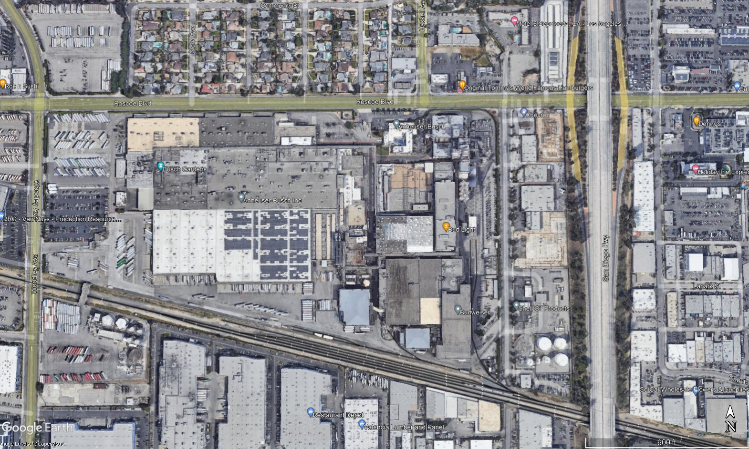

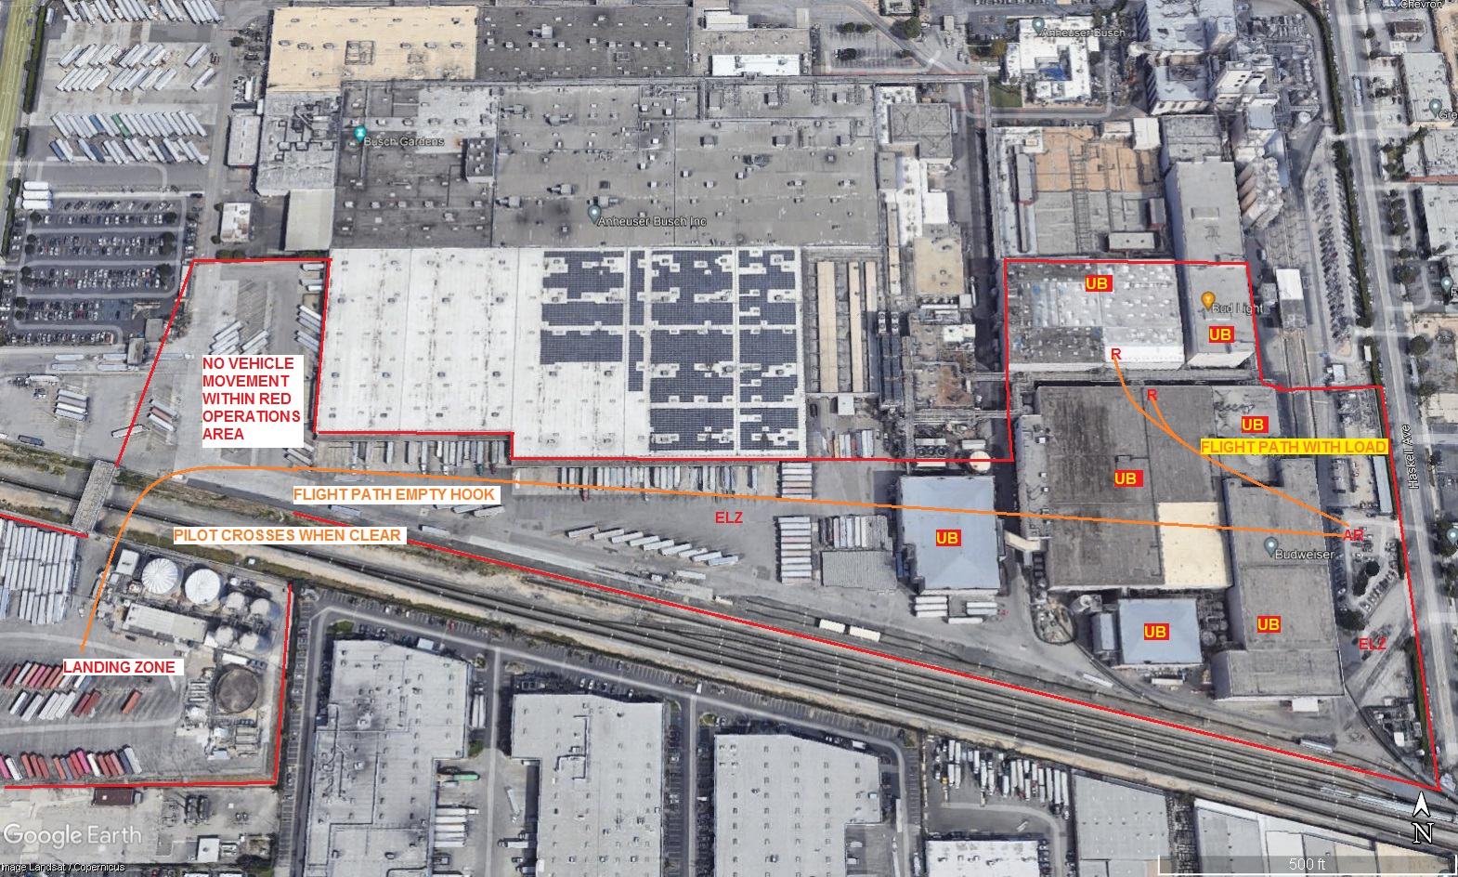
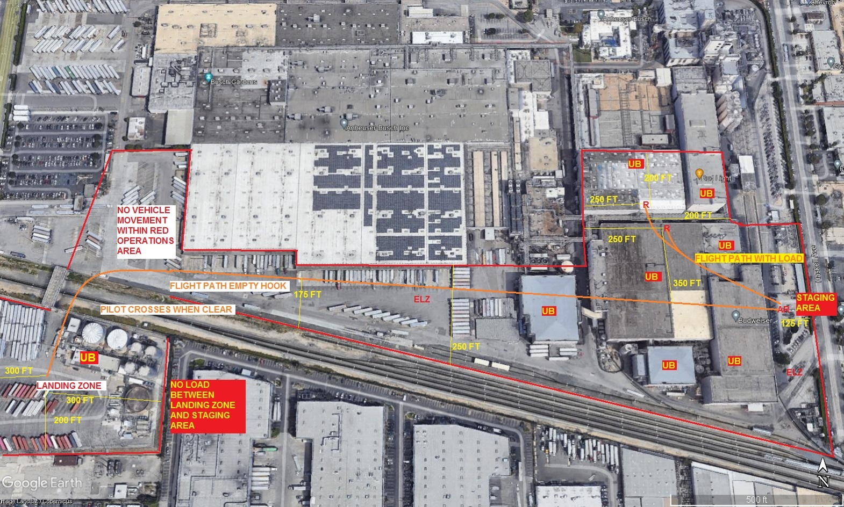

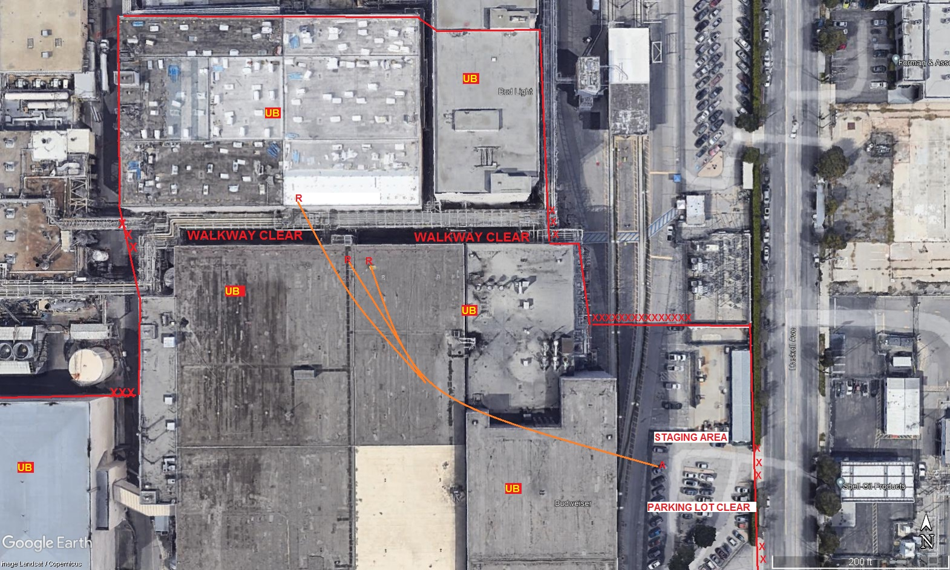
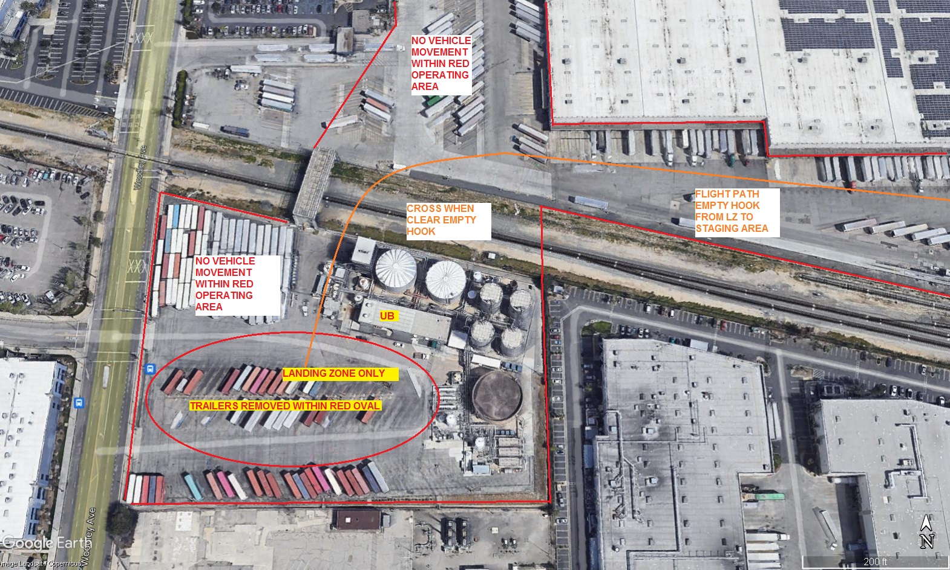
LEGEND
SITE PLAN SYMBOLS: EVACUATION FLIGHT PATH
LANDING AREA = (LZ) | STREET BLOCKED = XXXX | TOP TWO FLOORS = UBT2
ATTACH AREA = (A) | RELEASE AREA = (R)
FLIGHT PATH = >>> | EMERGENCY LAND = (ELZ)
UNOCCUPIED BUILDING = (UB) | UNOCCUPIED BUILDING TOP FLOOR = (UBT1)

11-9-2021 
DATE OF SUBMISSION COMPANY OFFICIAL / TITLE
Jeffrey M. Teubner Flight Coordinator

