
SECTION 7 Part 135 GH 4A Part 133 GH 4L
NON- Congested Area Plan
Operator: Guardian Helicopters, Inc
67 D STREET Phone (818) 442-9904
Fillmore CA. 93015 FAX (818) 442-9901
PROJECT: PG&E POLE SET AND HEC WORK ORDER #: 22-00356 22-00406
ADDRESS: SANTA ROSA CREEK ROAD CITY: TEMPLETON STATE: CA
LZ 35°32'40.80"N 120°52'8.97"W
101947978 35°34'5.40"N 120°58'3.60"W
101860273 35°35'10.80"N 120°56'27.60"W
101946085 35°33'52.36"N120°57'40.29"W
101883544 35°34'24.06"N120°58'17.87"W
SEE ATTACHED FLIGHT REQUEST AND KMZ FILE
CONTACT REQUESTOR: HELEN M. SANTORO PHONE#: 408-204-6987
CONTACT FORMAN: ROBERT E RAEL PHONE#: 805-459-7148
PILOT’S NAME(S):
1. MICHAEL KLINK CERT#: 3018828
2. BUCKEY MACKAY CERT #: 2778051
3. IAN GOODALE CERT#: 3741973
4. ROSS GOULET CERT#: 3396777
5. TREVOR NEEDHAM CERT#:3597668
TYPE OF AIRCRAFT:
BELL UH-1H N# N777GH A/C CATEGORY: RESTRICTED
BELL 407 N# N407GH A/C CATEGORY: STANDARD
BELL 407 N# N447GH A/C CATEGORY: STANDARD
BELL 205A1 N# N216GH A/C CATEGORY: STANDARD
BELL 205A1 N# N211GH A/C CATEGORY: STANDARD
AS350 B2 N# N498PT A/C CATEGORY: STANDARD
AS350BA N# N55TV A/C CATEGORY: STANDARD
IF SAFETY DICTATES AND OR THE CUSTOMER REQUESTS ADDITIONAL LIFTS THE LIFTS WILL BE CONDUCTED REMAINING WITHIN THE APPROVED TIME PARAMETERS.
TYPE OF LIFTS: (2) POLE SET 45 CL 2 1750 LBS LOAD:EXT CL B TYPE OF ITEM LIFTING: AERODYNAMIC NON- AERODYNAMIC LONG LINE: (NO) (YES) XXX LESS 200 FT (LENGTH) OPERATIONAL ALTITUDE: < 250 AGL STREET CLOSING: (N0) XX (YES)
DATE AND TIMES OPERATION WILL BEGIN AND TERMINATE:
FLIGHT DATES | TIME BEGIN | TIME END | TODAY’S DATE
3-10-2022 | SUNRISE | SUNSET | 2-28-2022
AGENCY NAME: | PHONE#: | PERSON NOTIFIED: | DATE:
PISMO BEACH POLICE DEPARTMENT | 805-773-2208 | DISPATCH | NOTIFIED
CALFIRE SLO COUNTY FIRE DEPARTMENT |  | DISPATCH | NOTIFIED
Evacuation Crowd Control Street Closure
No Evacuated Structures Operator Yes □No
□Evacuated Structures Contractor Contractor
□Operator

Part 135 GH 4A Part 133 GH 4L
NON Congested Area Plan
LIST OF BUILDINGS THAT SHALL EITHER BE PARTIALLY OR ENTIRELY UNOCCUPIED PERSONS ALSO HOMES THAT WILL BE NOTIFIED OF ACTIVITY:

BUILDING DESCRIPTION/ADDRESS | REMARKS | METHOD
NONE | VACANT DURING OPS | HAND DELIVER
Narrative description of pick-up site, route, delivery site, and plan for ceasing operation if unauthorized persons enter operational area or real hazard occurs.
SITE INSPECTION NOTES
ONLY PERSONNEL ESSENTIAL TO COMPLETING THE JOB SAFELY WILL BE PERMITTED TO PARTICIPATE IN THE EVOLUTION. ONLY PERSONNEL PARTICIPATING IN THE SAFETY BRIEF WILL BE PERMITTED TO BE IN THE AREA OF OPERATIONS. ONLY AUTHORIZED ESSENTIAL PERSONAL WILL BE PERMITTED IN THE IMMEDIATE AREA OF OPERATIONS. IN THE EVENT AN UNAUTHORIZED PERSON ENTERS THE OPERATIONS AREA OR A POTENTIAL
HAZARD IS IDENTIFIED THE PILOT WILL HOLD THE AIRCRAFT IN RELATIVE POSITION. THIS WILL BE ACHIEVED WITHOUT OVER FLYING THE GROUND CREW. ALL OPERATIONS WILL BE CEASED UNTIL THE PROBLEM IS RECTIFIED. IN THE EVENT OF AN AIRCRAFT EMERGENCY, THE PILOT WILL RADIO GROUND PERSONNEL AND WILL ATTEMPT TO LAND IN THE EMERGENCY LANDING AREA.
DURING THE LIFT EVOLUTION THE AIRCRAFT AND GROUND CREW WILL ALL BE IN RADIO COMMUNICATIONS. IN THE EVENT OF LOSS COMMUNICATIONS, THE CREW WILL USE STANDARD HAND SIGNALS TO COMMUNICATE WITH THE PILOT. WHEN THE PILOT IS CLEAR HE WILL MOVE THE AIRCRAFT TO A SAFE LOCATION TO ALLOW THE COMMUNICATION PROBLEM TO BE RECTIFIED.
THE OPERATIONS AREA IS WITHIN THE SECURED AREA. ALL ESSENTIAL CREW WITHIN THE OPERATIONS AREA WILL NOT BE INVOLVED IN TAKING PICTURES OR ANY OTHER USE OF CELL PHONES.

PRIOR TO BEGINNING OPERATIONS, A TAILBOARD SAFETY BRIEF WILL BE CONDUCTED.

- BOTH HELICOPTERS WILL LAND AT THE LZ STAGING AREA TO CONDUCT A TAILBOARD.
- HEC TRAINING WILL BE CONDUCTED AT THE LZ
- WATER TRUCK REQUIRED AT LZ STAGING AREA
- POLES WILL BE STAGED AT STAGING AREA
- NO EVACUATIONS
- IF REQUIRED FLAGMAN WILL PROVIDE TEMP. STREET CLOSURE

LEGEND
SITE PLAN SYMBOLS: EVACUATION FLIGHT PATH
LANDING AREA = (LZ) | STREET BLOCKED = XXXX | TOP TWO FLOORS = UBT2
ATTACH AREA = (A) | RELEASE AREA = (R)
FLIGHT PATH = >>> | EMERGENCY LAND = (ELZ)
UNOCCUPIED BUILDING = (UB) | UNOCCUPIED BUILDING TOP FLOOR = (UBT1)

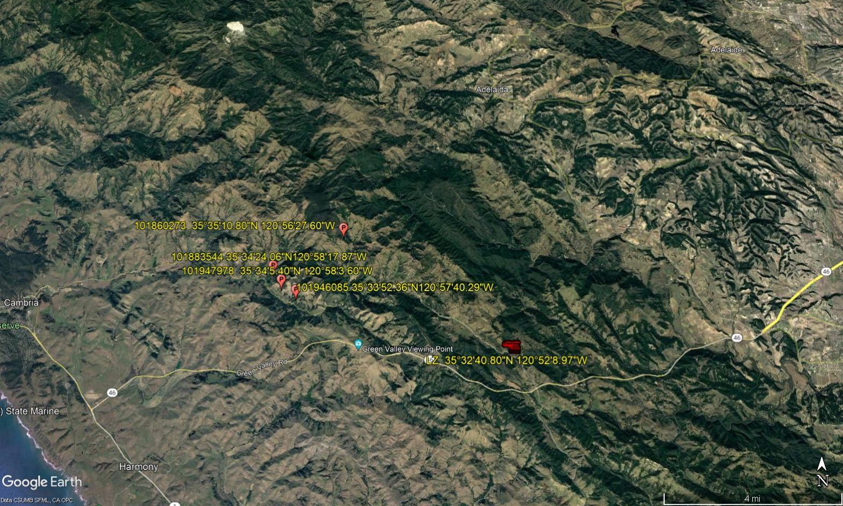
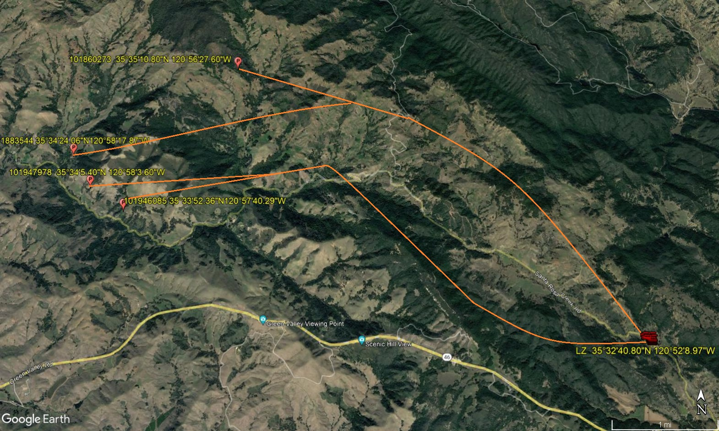
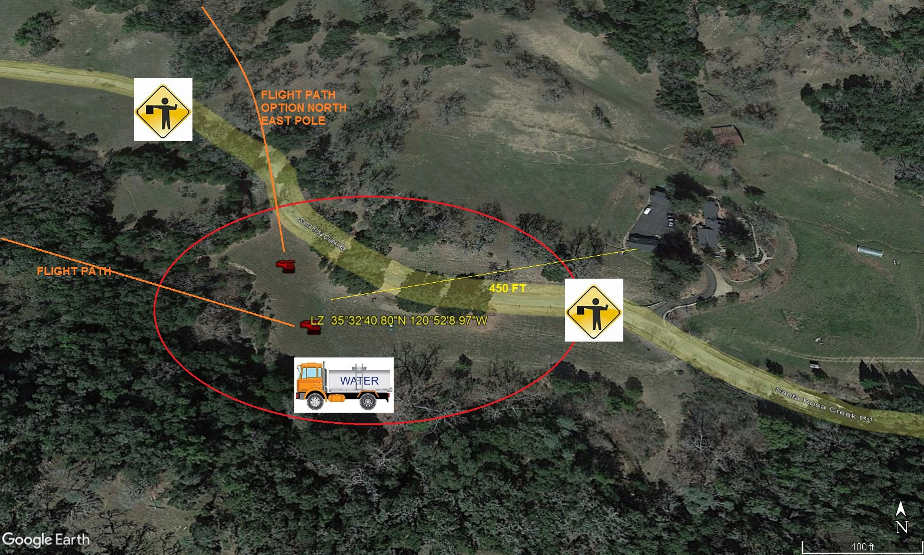
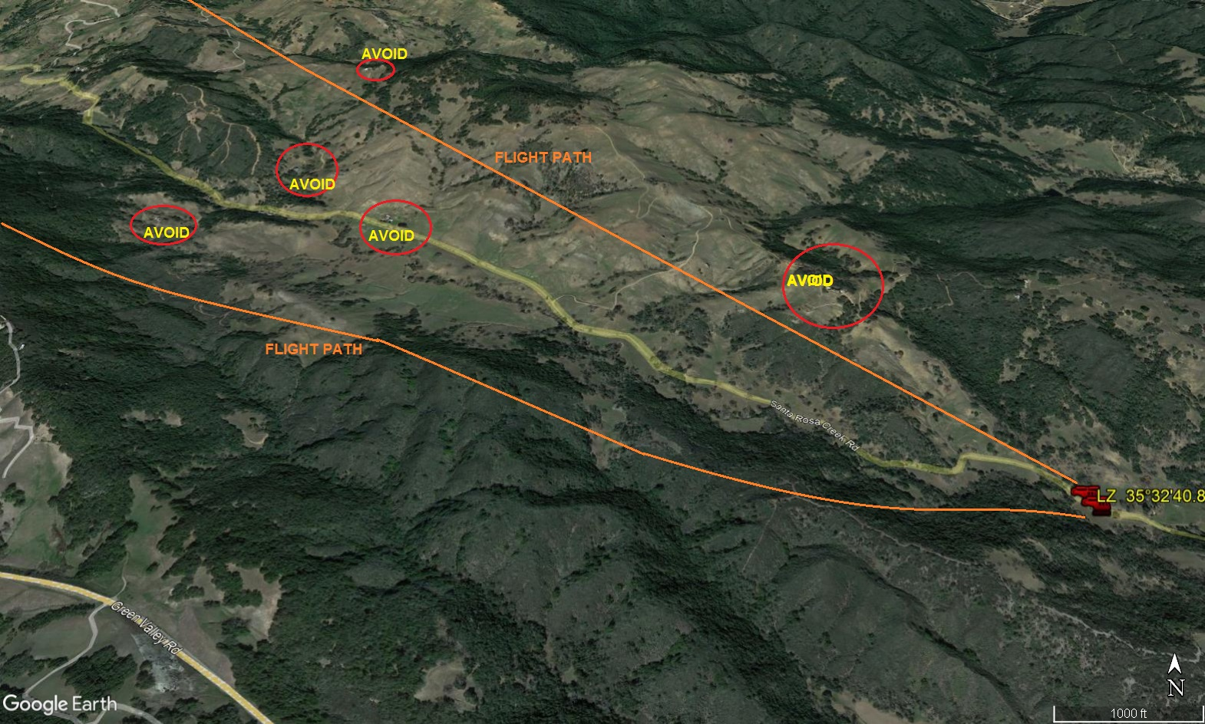
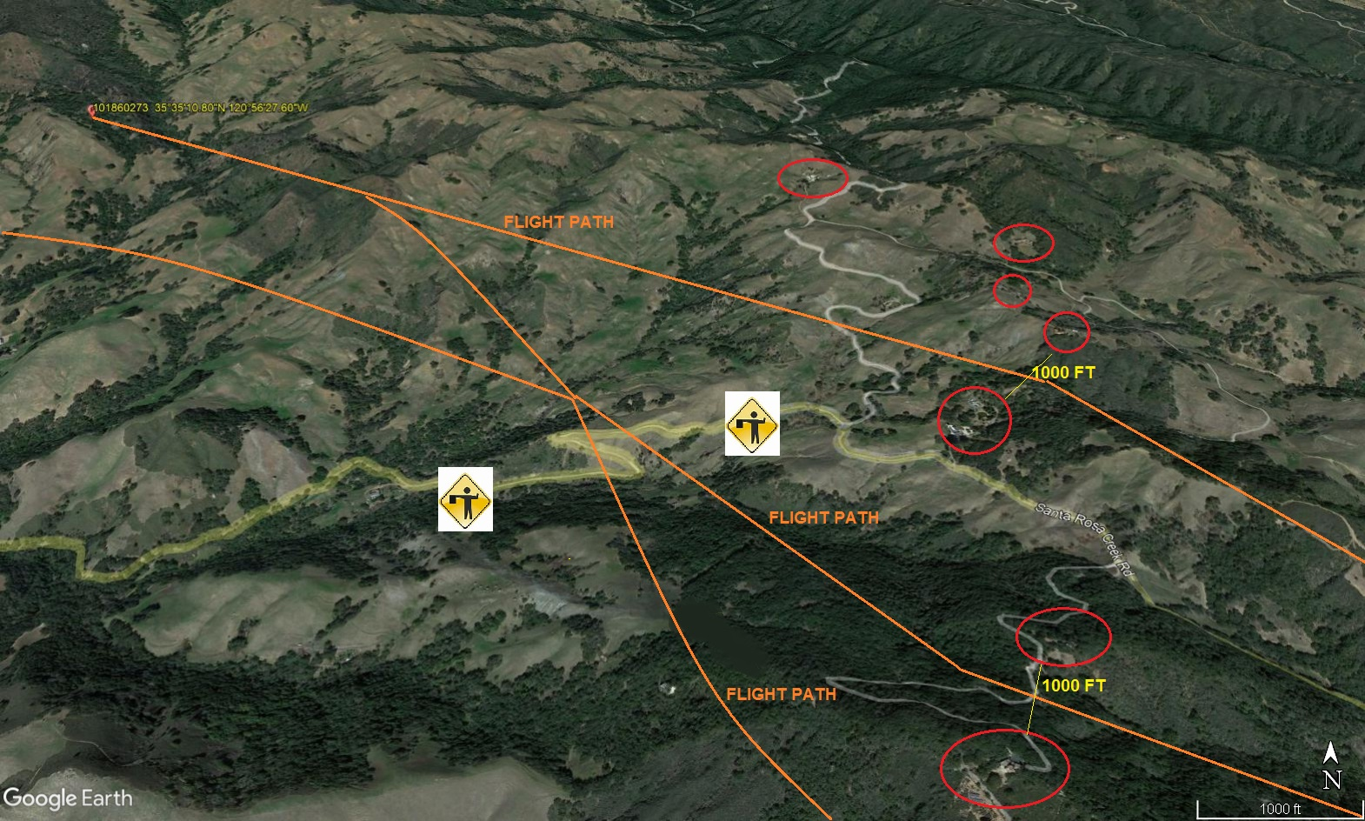
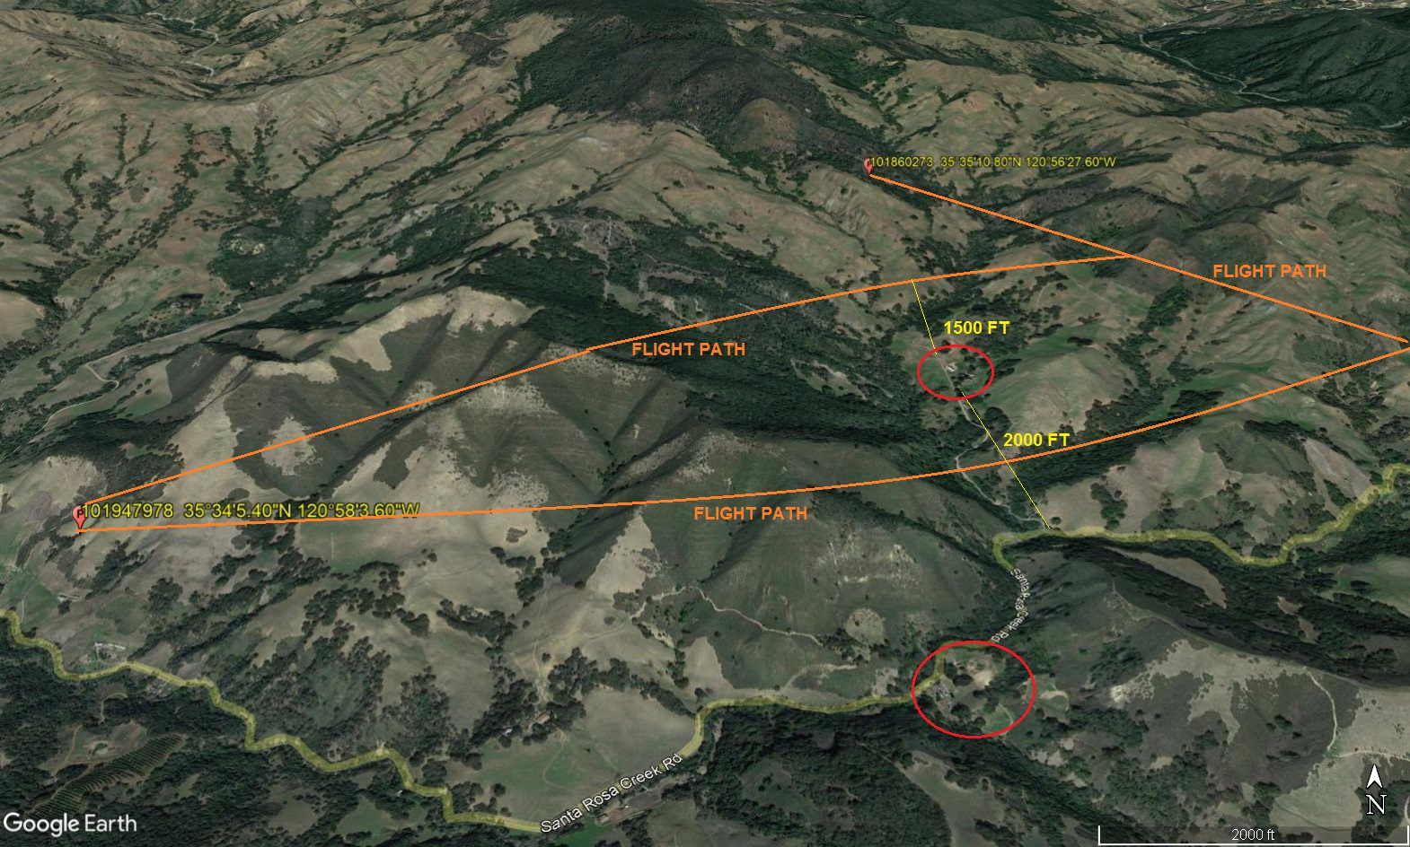
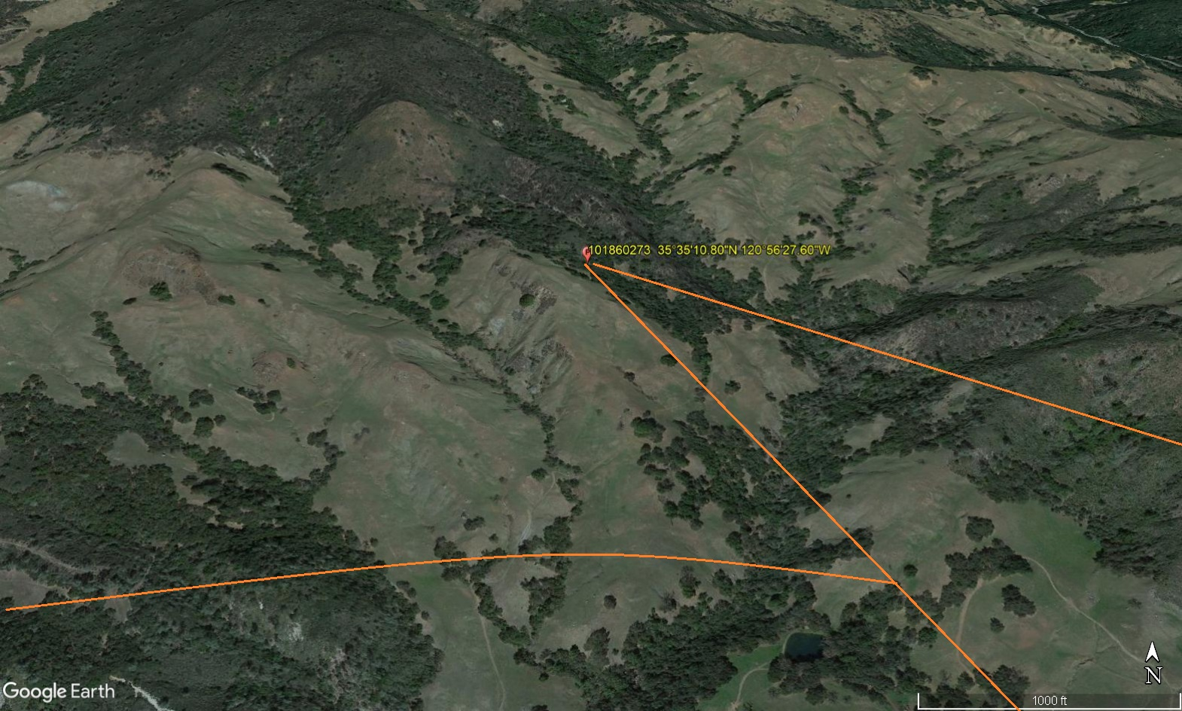
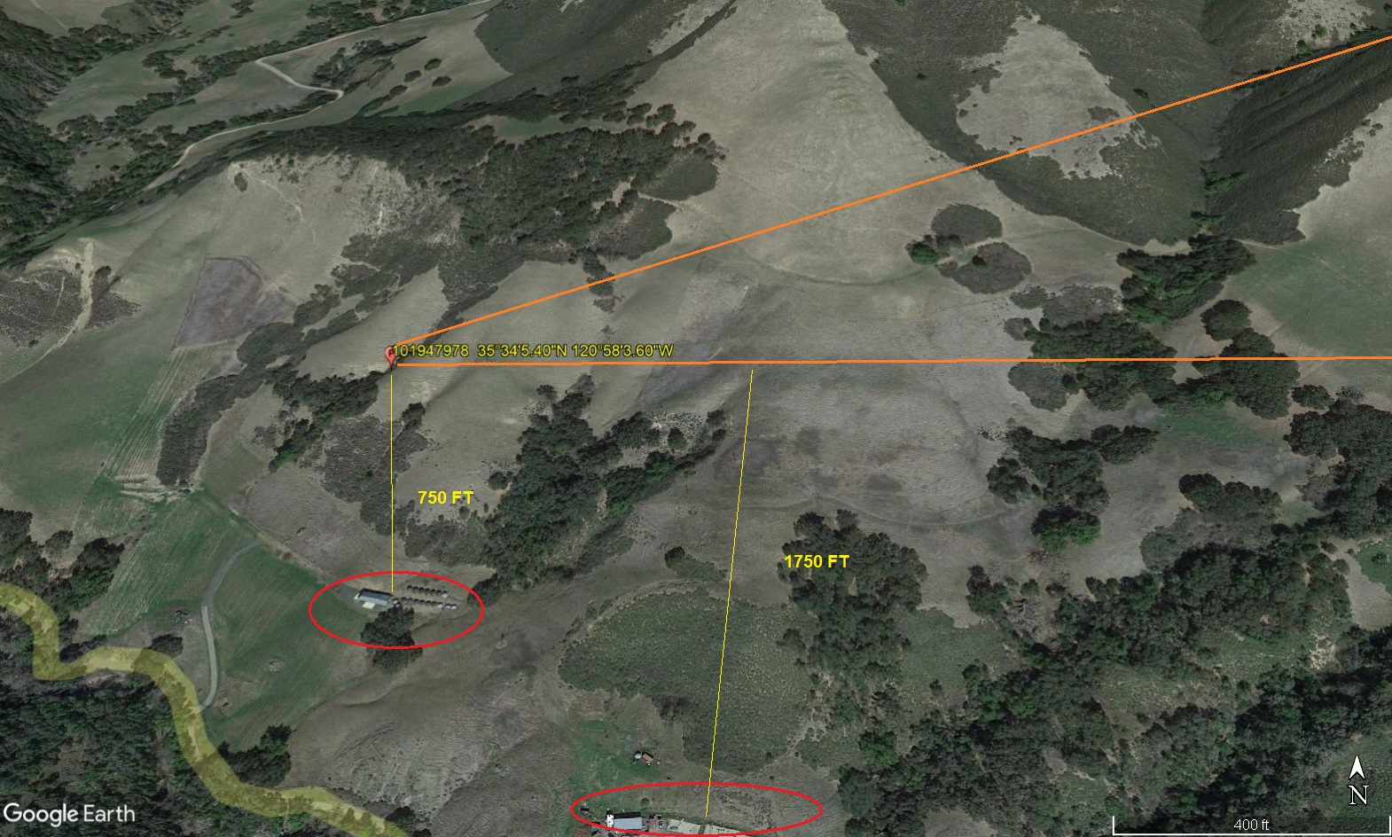
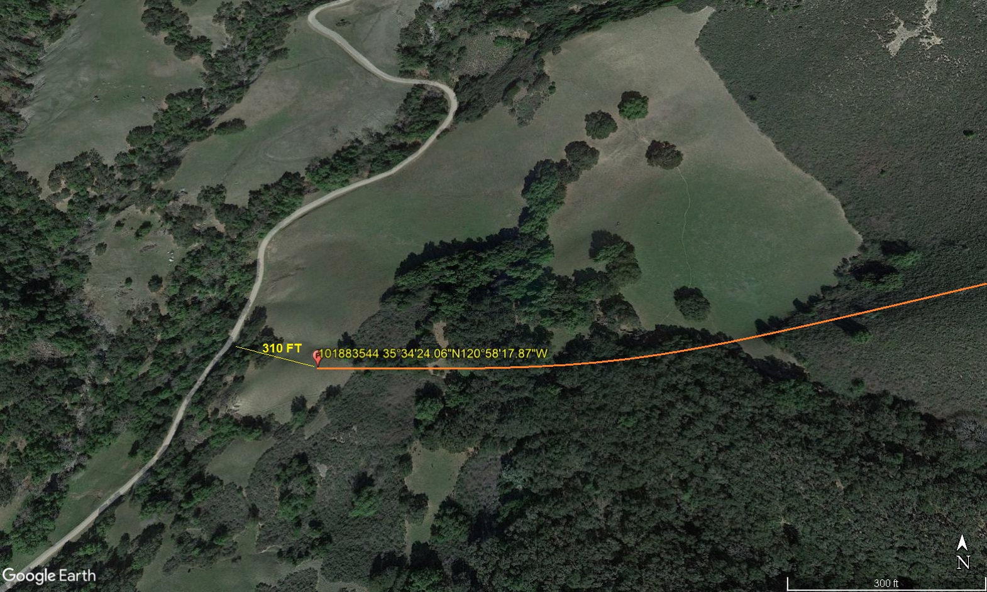
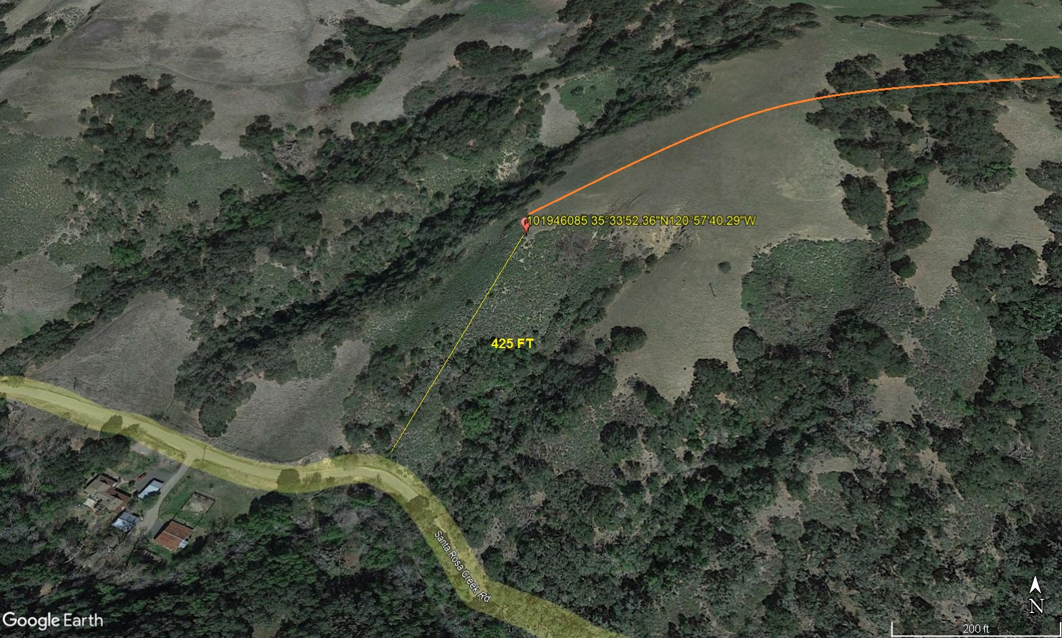
12-28-2022 
DATE OF SUBMISSION COMPANY OFFICIAL / TITLE
Jeffrey M. Teubner Flight Coordinator

