
SECTION 7 Part 135 GH 4A Part 133 GH 4L
NON- Congested Area Plan
Operator: Guardian Helicopters, Inc
67 D STREET Phone (818) 442-9904
Fillmore CA. 93015 FAX (818) 442-9901
PROJECT: PG&E BHT 205 CAPS TOP WORK ORDER #: 25-03147
ADDRESS: 5 FREEWAY CITY: FIREBAUGH STATE: CA ZIP: 93622
SEE ATTACHED FLIGHT REQUEST AND KMZ
CONTRACTOR: PGE
CONTACT REQUESTOR: GEORGE E SOARES PHONE#: xxx-xxx-xxxx
CONTACT FORMAN: KYLE GUSTAFSON PHONE#: 559-287-8450
CONTACT SUPERVISOR : GEORGE E SOARES PHONE#: xxx-xxx-xxxx
PILOT’S NAME(S):
1. MICHAEL KLINK CERT#: 3018828
2. BUCKEY MACKAY CERT #: 2778051
3. IAN GOODALE CERT#: 3741973
4. ROSS GOULET CERT#: 3396777
5. TREVOR NEEDHAM CERT#: 3597688
6. DONOVAN OWENS CERT#: 3403431
TYPE OF AIRCRAFT: BELL UH-1H N# N777GH A/C CATEGORY: RESTRICTED
BELL 407 N# N407GH A/C CATEGORY: STANDARD
BELL 407 N# N447GH A/C CATEGORY: STANDARD
BELL 407 N# N111GH A/C CATEGORY: STANDARD
BELL 407 N# N718GH A/C CATEGORY: STANDARD
BELL 407 N# N829GH A/C CATEGORY: STANDARD
BELL 205A1 N# N216GH A/C CATEGORY: STANDARD
BELL 205A1 N# N211GH A/C CATEGORY: STANDARD
BK 117 N# N817DD A/C CATEGORY: STANDARD
BK 117 N# N1174U A/C CATEGORY: STANDARD
BK 117 N# N74GH A/C CATEGORY: STANDARD
IF SAFETY DICTATES AND OR THE CUSTOMER REQUESTS ADDITIONAL LIFTS THE LIFTS WILL BE CONDUCTED REMAINING WITHIN THE APPROVED TIME PARAMETERS.
TYPE OF LIFT: HEC CARGO LOAD: EXT CL B TYPE OF ITEM LIFTING: AERODYNAMIC NON- AERODYNAMIC LONG LINE: (NO) XXX (YES) LESS 200 FT (LENGTH)
DATE AND TIMES OPERATION WILL BEGIN AND TERMINATE:
FLIGHT DATES | TIME BEGIN | TIME END | TODAY’S DATE
SEE PGE FLIGHT REQUEST | SUNRISE | SUNSET | 11-10-2025
AGENCY NAME: | PHONE#: | PERSON NOTIFIED: | DATE:
Evacuation Crowd Control Street Closure
No Evacuated Structures Operator Yes □No
□Evacuated Structures Contractor Contractor
□Operator

Part 135 GH 4A Part 133 GH 4L
NON-Congested Area Plan

LIST OF BUILDINGS THAT SHALL EITHER BE PARTIALLY OR ENTIRELY UNOCCUPIED PERSONS ALSO HOMES THAT WILL BE NOTIFIED OF ACTIVITY:

BUILDING DESCRIPTION/ADDRESS | REMARKS | METHOD
NONE | NOTIFIED BY PGE | HAND CARRY
STRUCTURES WITHIN 300 FT

Narrative description of pick-up site, route, delivery site, and plan for ceasing operation if unauthorized persons enter operational area or real hazard occurs.

SITE INSPECTION NOTES
- ALL OPERATIONS WILL BE IN ACCORDANCE WITH GHI AND CONTACTOR’S POLICIES AND PROCEDURES.
- ALL PERSONNEL ESSENTIAL TO COMPLETING THE JOB SAFELY WILL PARTICIPATE IN THE SAFETY TAILBOARD. ALL PARTICIPANTS MUST SIGN THE GHI SIGN IN SHEET.
- ONLY ESSENTIAL PERSONNEL WILL BE PERMITTED TO PARTICIPATE IN THE EVOLUTION AND TO ENTER THE SAFETY ZONE.
- IN THE EVENT AN UNAUTHORIZED PERSON ENTERS THE SAFETY ZONE OR A POTENTIAL HAZARD IS IDENTIFIED THE PILOT WILL HOLD THE AIRCRAFT IN RELATIVE POSITION AND ALL OPERATIONS WILL CEASE UNTIL THE PROBLEM IS RECTIFIED.
- THE PILOT WILL MAINTAIN RADIO COMMUNICATION WITH THE GROUND CREW. IN THE EVENT OF LOSS COMMUNICATION, THE CREW WILL USE STANDARD HEAD AND HAND SIGNALS. WHEN THE PILOT IS CLEAR HE WILL MOVE THE AIRCRAFT TO A SAFE LOCATION TO ALLOW THE COMMUNICATION PROBLEM TO BE RECTIFIED.
- IN THE EVENT OF AN AIRCRAFT EMERGENCY THE PILOT WILL NOTIFY THE GROUND CREW AND WILL ATTEMPT TO LAND THE AIRCRAFT IN THE EMERGENCY LANDING AREA.
- NO PERSONNEL WITHIN THE OPERATING AREA WILL BE PERMITTED TO TAKE PICTURES, NO CAMERA OR CELL PHONE USAGE.
- EVACUATIONS AND STREET CLOSURES ARE IN ACCORDANCE WITH DIAGRAMS BELOW.
- ANY DEVIATION FROM THE FLIGHT PLAN OR TAILBOARD MUST BE RE TAIL BOARDED
- ANY DEVIATION OR ADDITIONAL WORK MUST BE APPROVED BY CONTRACTOR
- ALL PERSONNEL HAVE WORK STOP AUTHORITY AND MUST EXERCISE THIS AUTHORIZATION

PRIOR TO BEGINNING OPERATIONS, A TAILBOARD SAFETY BRIEF WILL BE CONDUCTED.

- HELICOPTER WILL LAND AT THE LANDING ZONE TO CONDUCT TAILBOARD
- EQUIPMENT WILL BE STAGED AT LZ
- REMOTE AREA NO EVACUATIONS
- CAL TRANS IN PLAC3E ON FREEWAY 5 STREET CLOSURES
- WATER TRUCK IS REQUIRED AT LANDING AREAS

LEGEND
SITE PLAN SYMBOLS: EVACUATION FLIGHT PATH
LANDING AREA = (LZ) | STREET BLOCKED = XXXX | TOP TWO FLOORS = UBT2
ATTACH AREA = (A) | RELEASE AREA = (R)
FLIGHT PATH = >>> | EMERGENCY LAND = (ELZ)
UNOCCUPIED BUILDING = (UB) | UNOCCUPIED BUILDING TOP FLOOR = (UBT1)

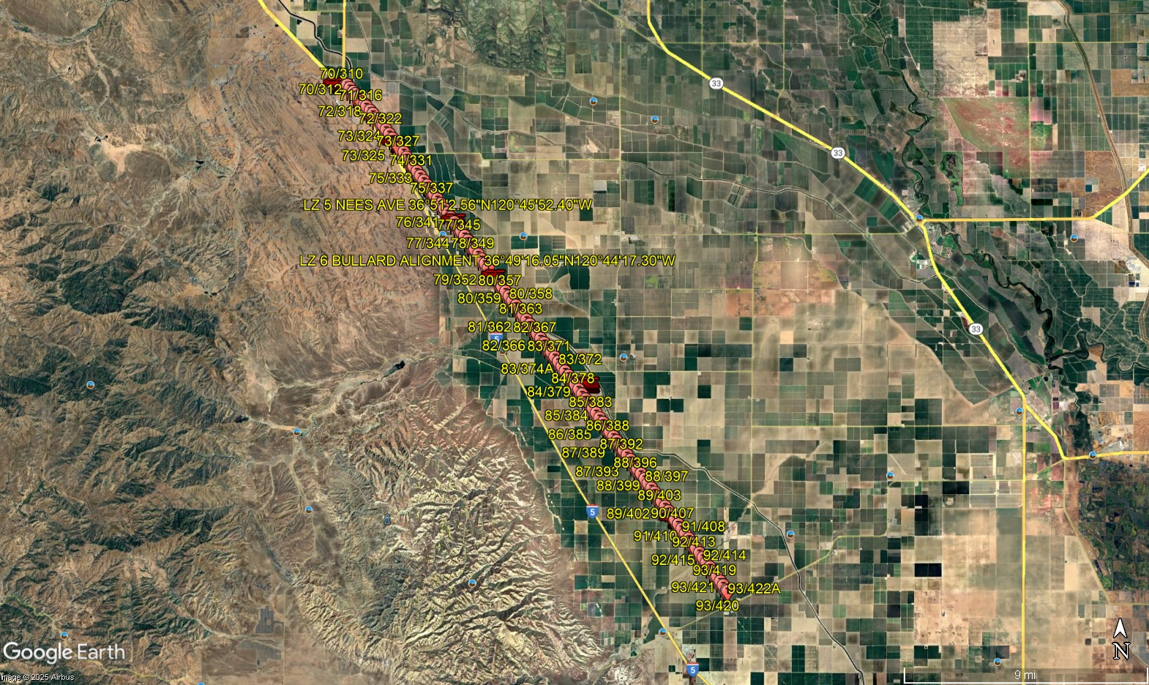
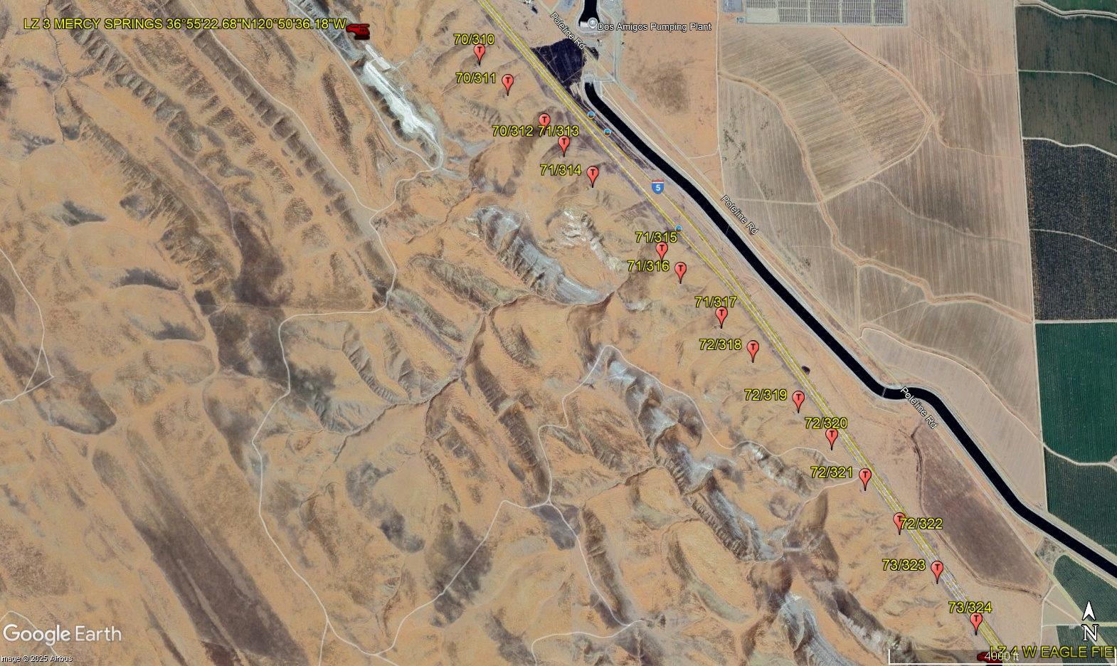
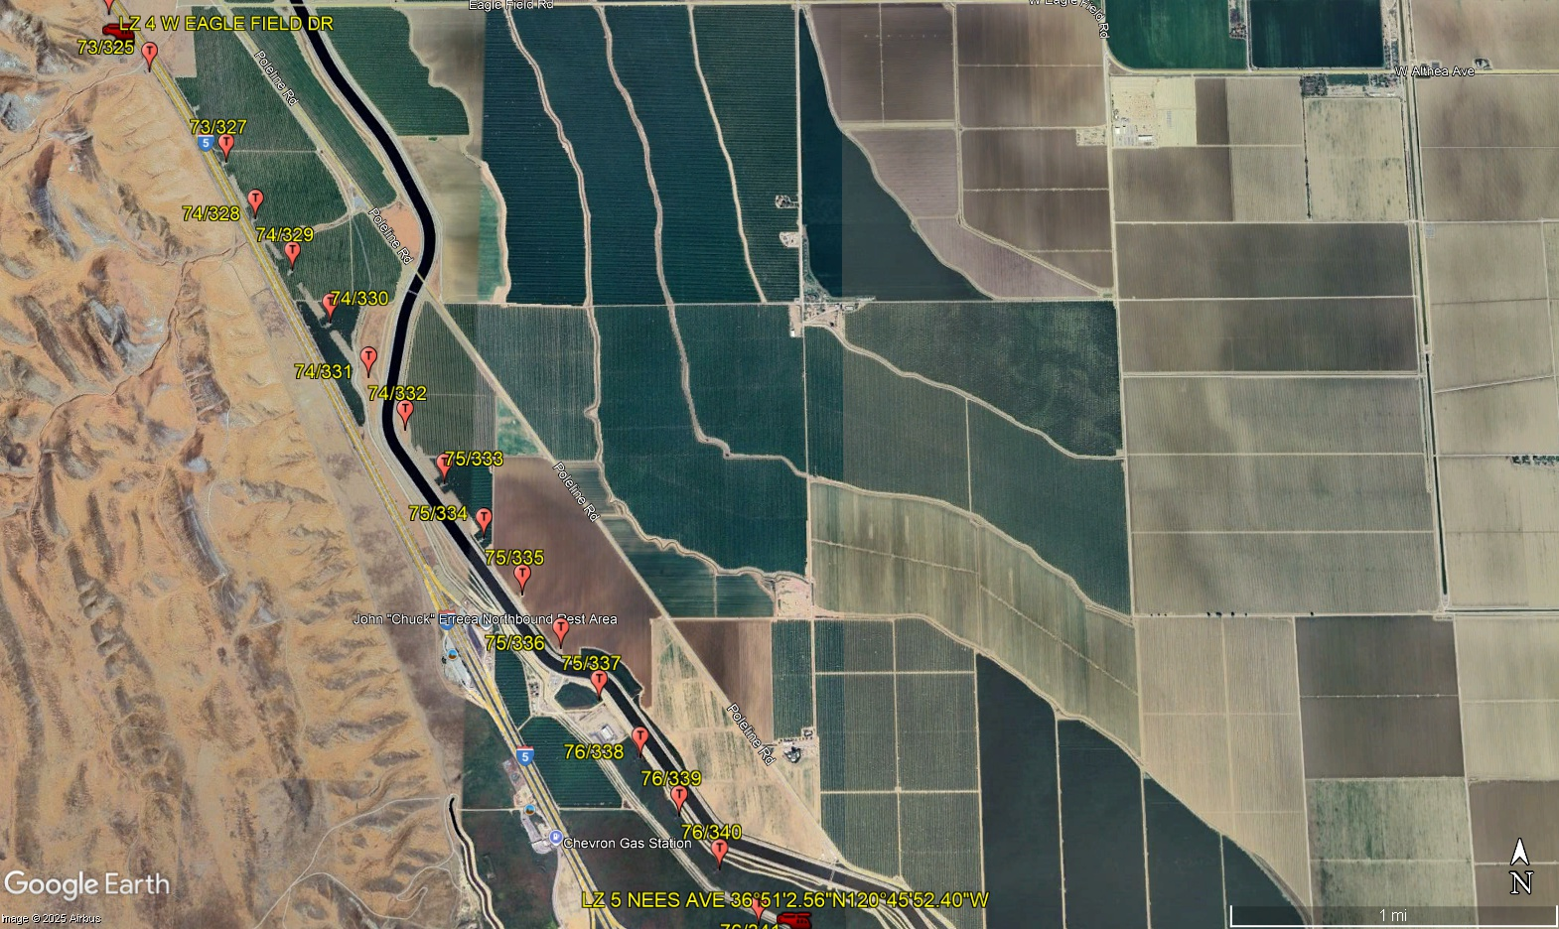
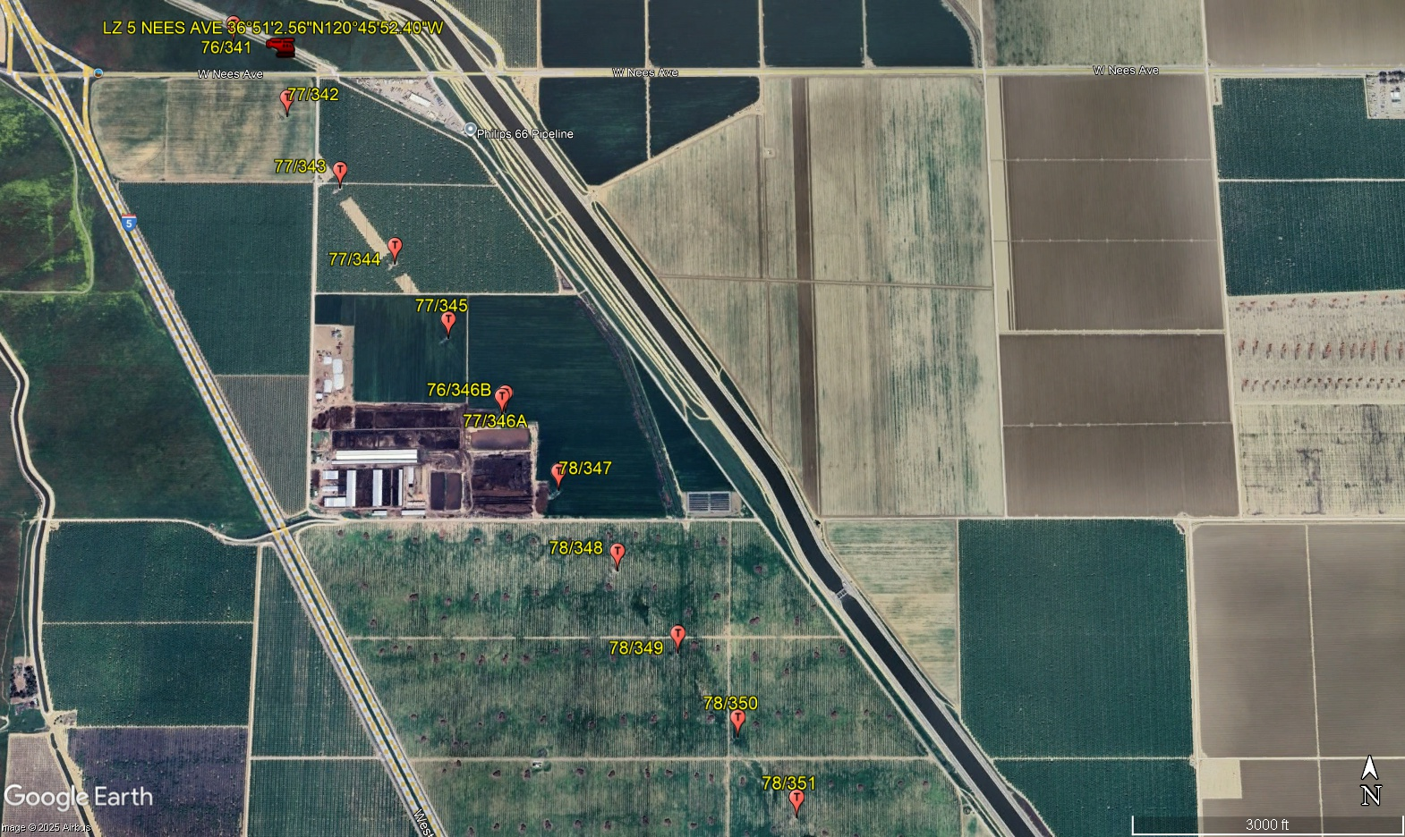
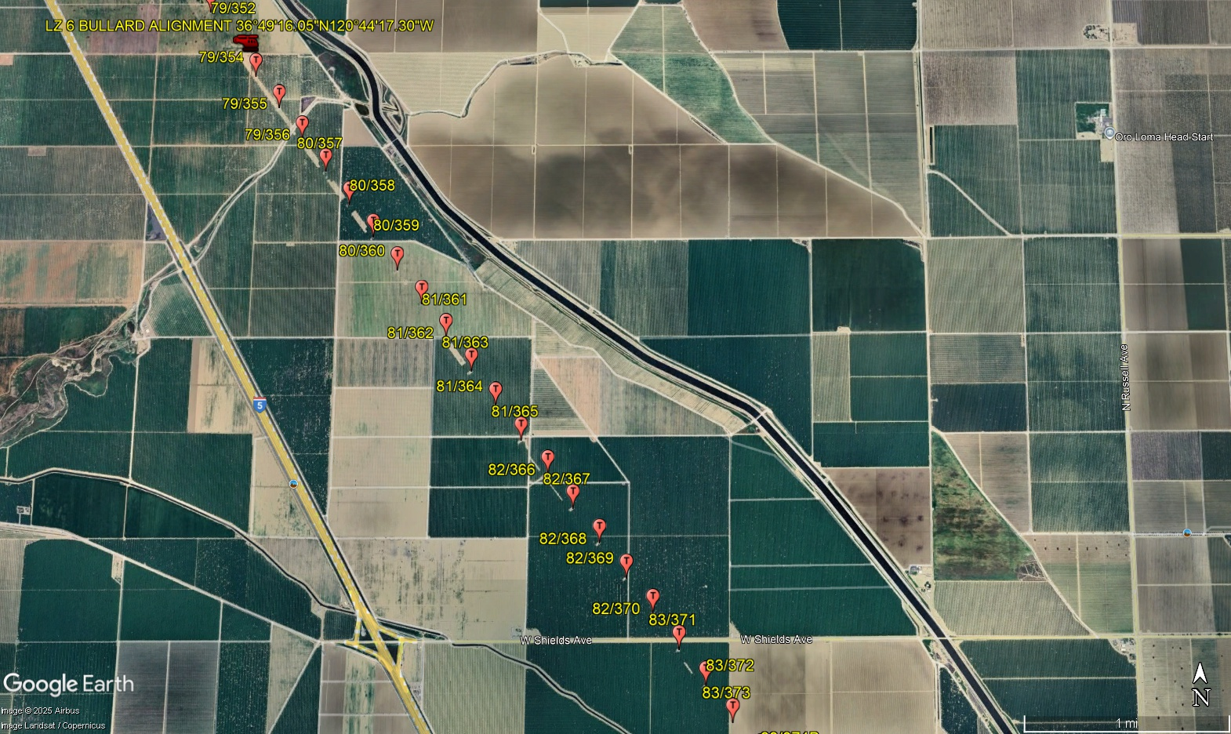
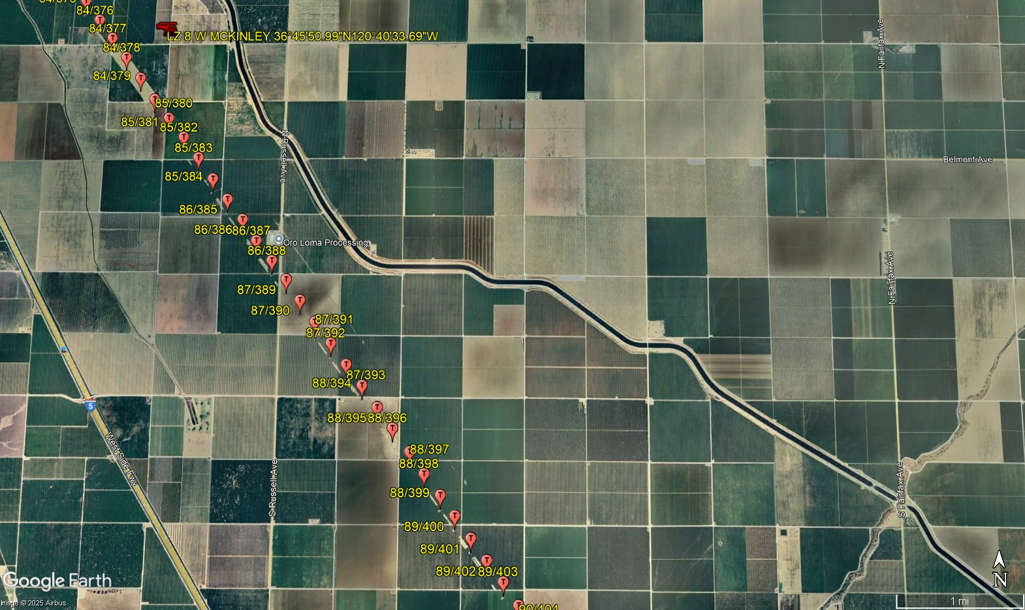
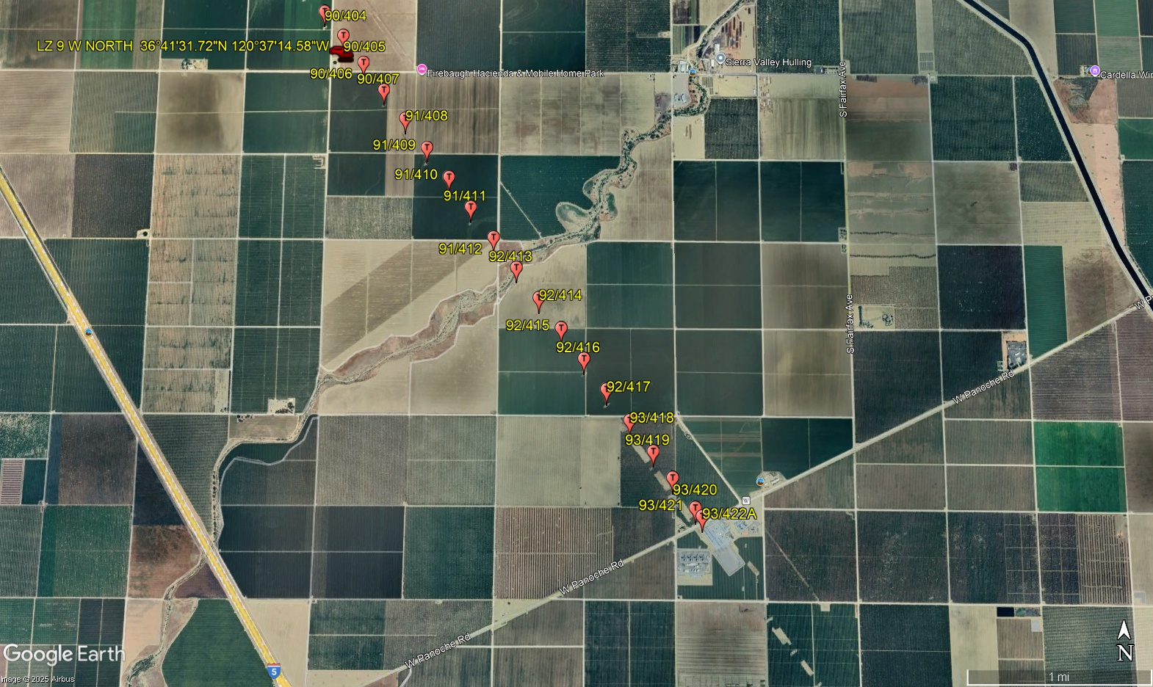
11-10-2025 
DATE OF SUBMISSION COMPANY OFFICIAL / TITLE
Jeffrey M. Teubner Flight Coordinator

